CLIMATE SCOPE

1. Introduction
The Global Weather Data Analysis Dashboard project aims to analyze and visualize global weather datasets to extract insights such as temperature patterns, humidity levels, and extreme weather events. Using Python, Streamlit, and Plotly, an interactive dashboard was developed to help users explore weather data in a visual and user-friendly format.

2. Requirements
- Python 3.10 or later
- Libraries: Pandas, NumPy, Streamlit, Plotly, Seaborn, Matplotlib
- Git & GitHub for version control
- IDE: Visual Studio Code
- Dataset: GlobalWeatherRepository.csv (raw)

3. Milestone 1 – Data Collection and Cleaning
The dataset was first collected and loaded using Pandas. Missing values and anomalies were identified and handled. Units were standardized, such as converting Fahrenheit to Celsius and miles to kilometers. Normalization was applied to numeric data.
Key Implementation Code:
df = pd.read_csv('GlobalWeatherRepository.csv')
df.drop_duplicates(inplace=True)
df['last_updated'] = pd.to_datetime(df['last_updated'], errors='coerce')
df.fillna(df.mean(numeric_only=True), inplace=True)
df.to_csv('GlobalWeatherRepository_cleaned.csv', index=False)
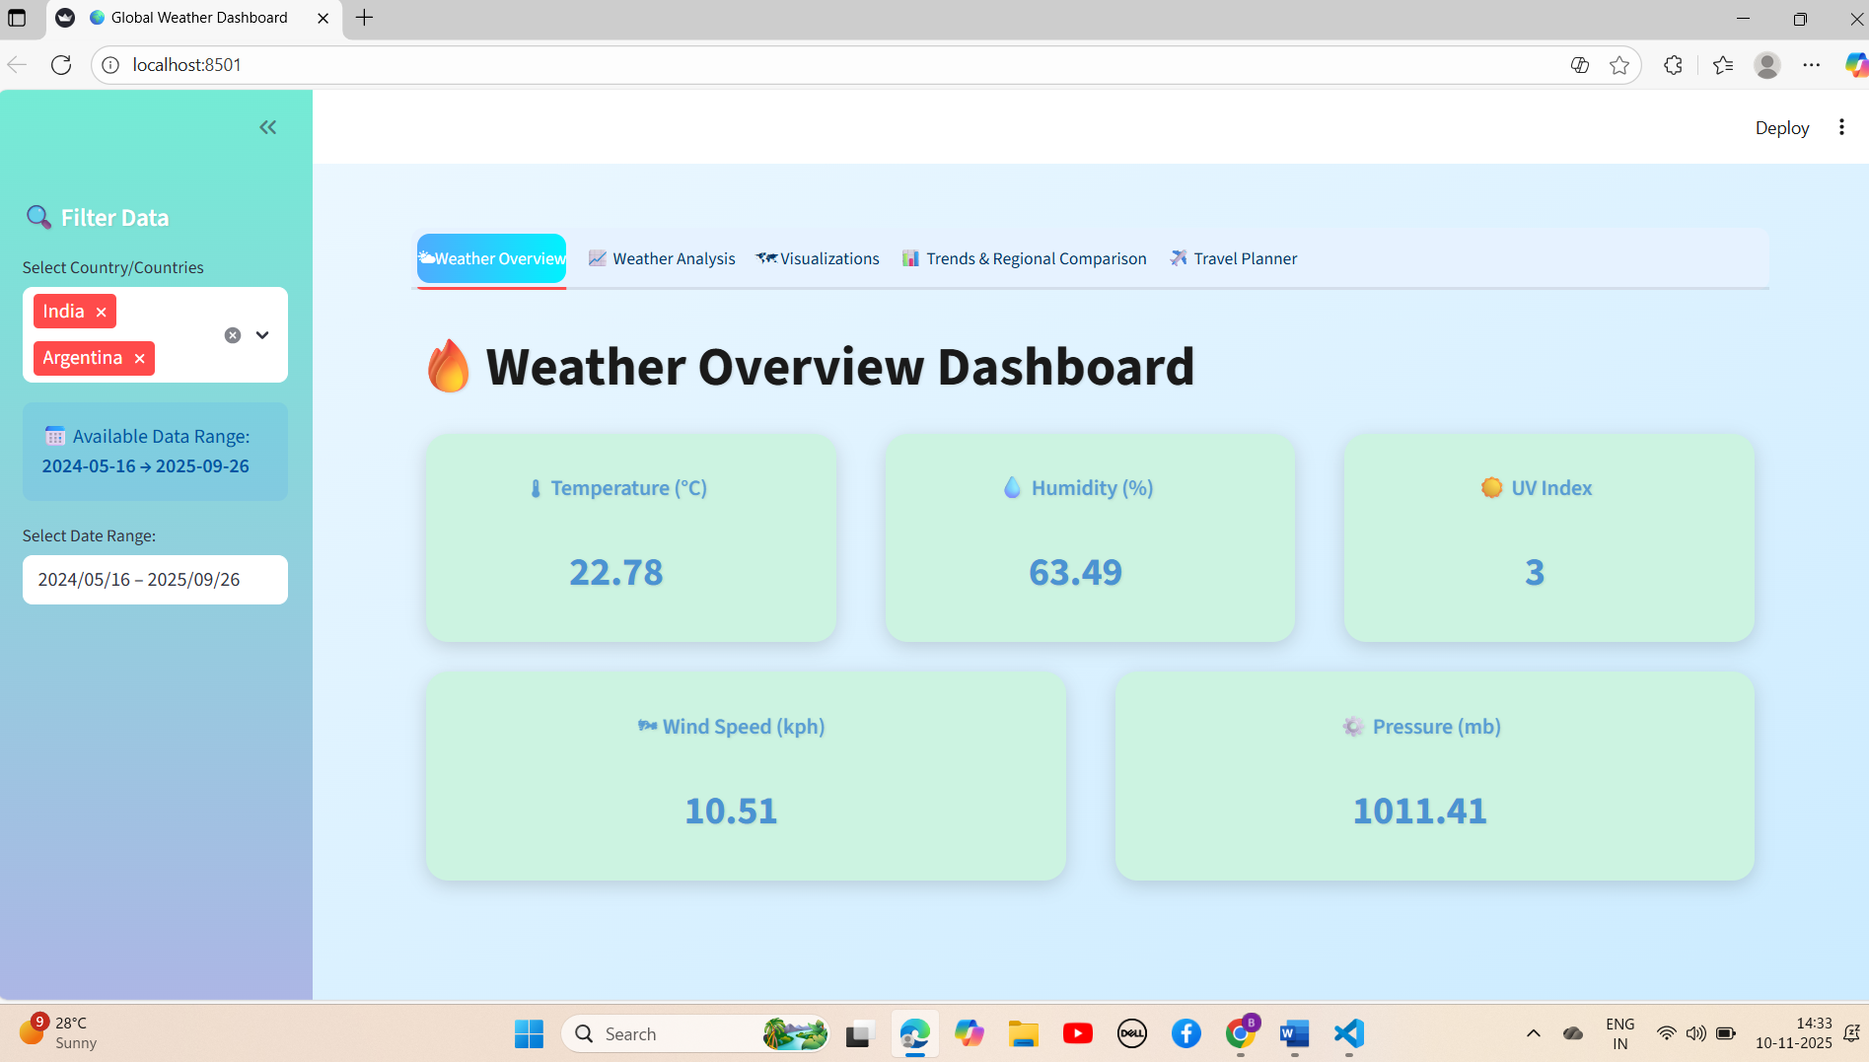

4. Milestone 2 – Statistical and Correlation Analysis
After cleaning, the dataset was statistically analyzed. Descriptive statistics helped understand data distributions. Correlation analysis was visualized using a heatmap to show relationships among weather parameters. Seasonal trend analysis was performed using monthly and yearly aggregation of data.
Key Feature Added: Correlation Heatmap
numeric_cols = ['temperature_celsius', 'humidity', 'wind_kph', 'precip_mm', 'uv_index']
corr = df[numeric_cols].corr()
fig = px.imshow(corr, color_continuous_scale='RdBu_r', zmin=-1, zmax=1, text_auto=True)
st.plotly_chart(fig, use_container_width=True) 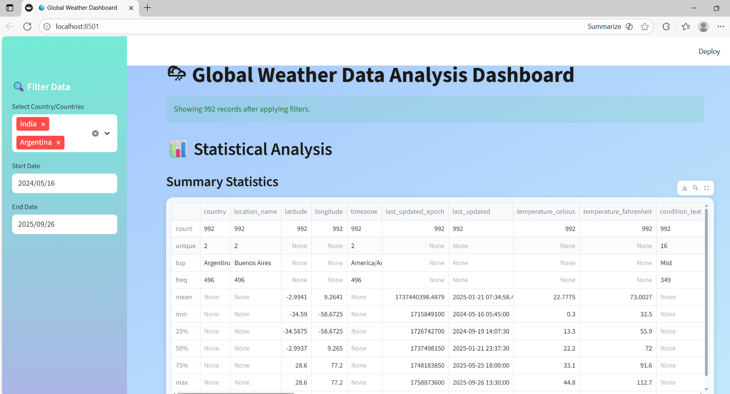
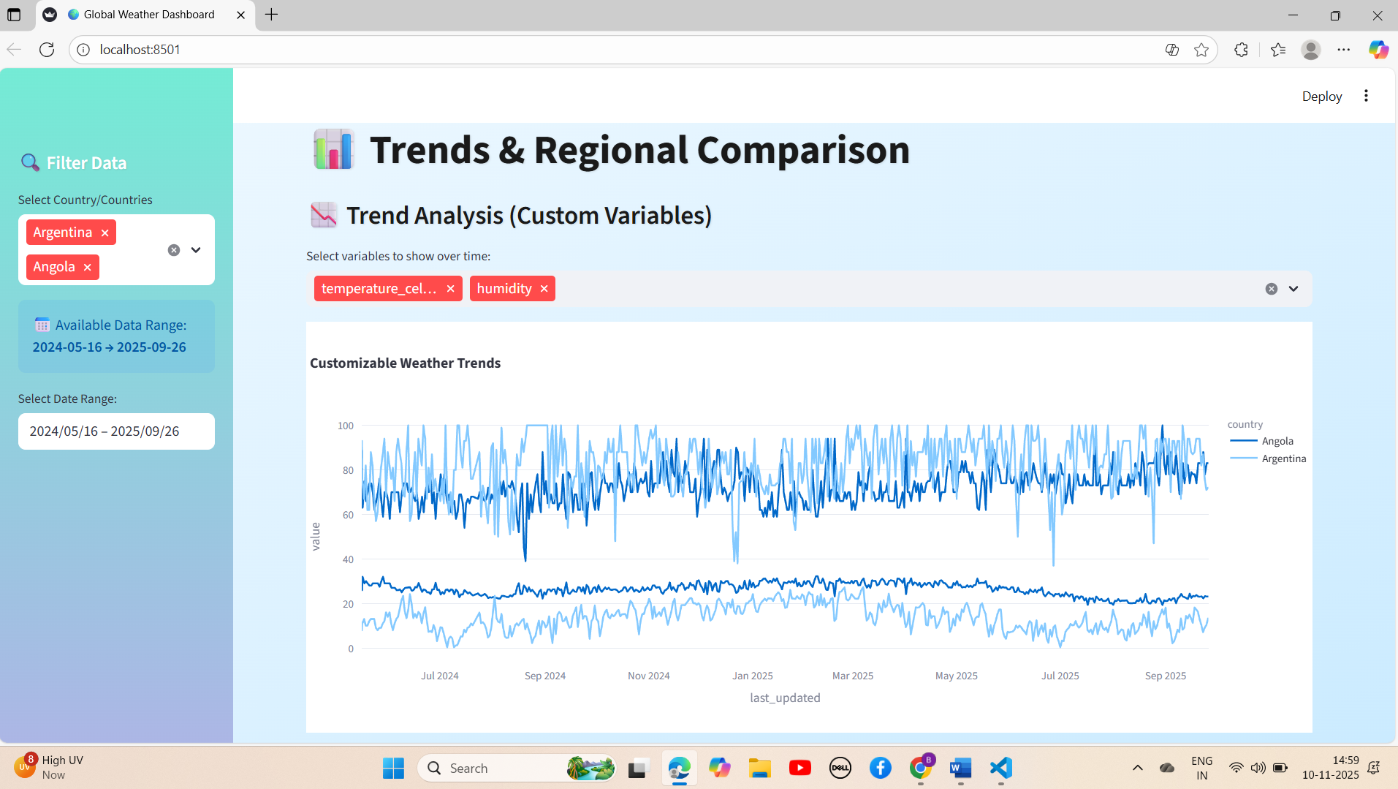

5. Milestone 3 – Dashboard Development and Interactivity
A Streamlit dashboard was developed with filters, date selectors, and dropdowns to interact with the data. Visualizations were made dynamic so users could select specific countries or time periods to focus on.
Interactive Feature Code Example:
selected_countries = st.sidebar.multiselect('Select Country', df['country'].unique())
start_date = st.sidebar.date_input('Start Date', df['last_updated'].min().date())
end_date = st.sidebar.date_input('End Date', df['last_updated'].max().date())
mask = (df['last_updated'].dt.date >= start_date) & (df['last_updated'].dt.date <= end_date)
if selected_countries:
mask &= df['country'].isin(selected_countries)
df_filtered = df[mask]
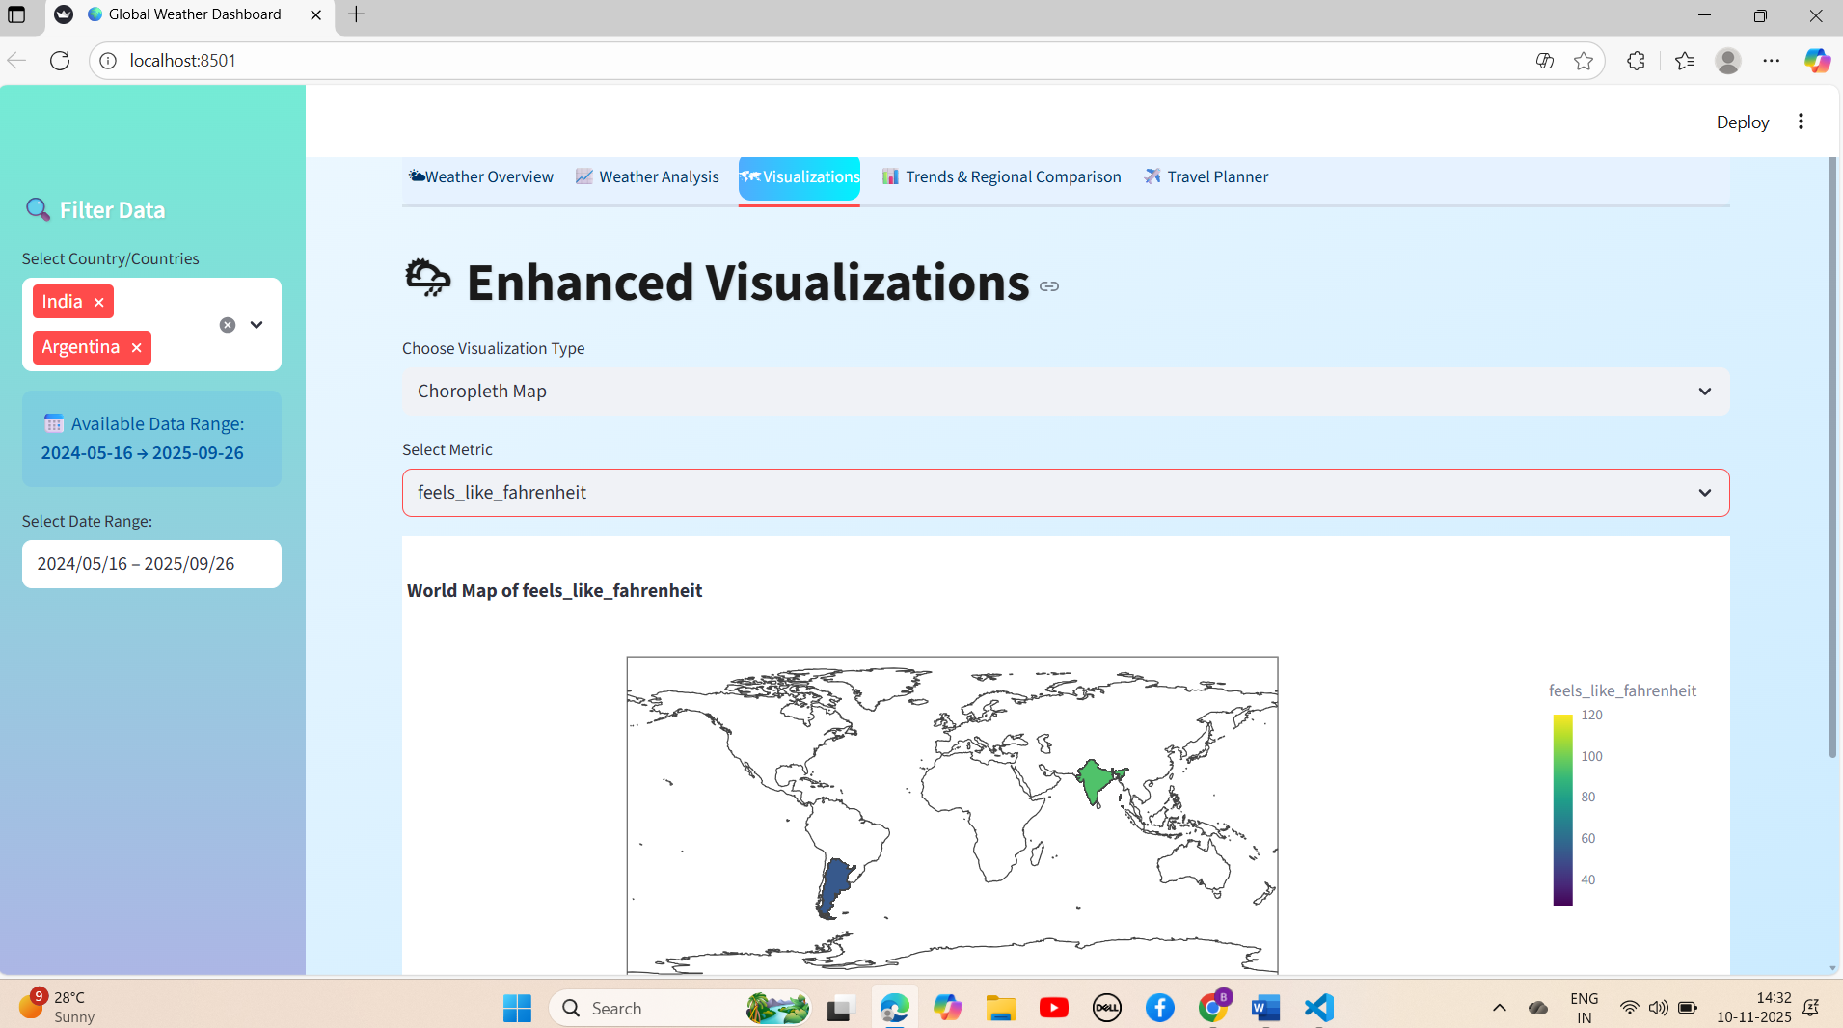

6. Milestone 4 – Aesthetic and Functional Enhancements
The dashboard was visually enhanced using CSS to create gradient backgrounds and improved UI cards. Tabs were introduced for different analyses like trends, comparisons, and travel planning. Extreme weather events were also identified and displayed interactively.
Added Features: Gradient Theme and Extreme Weather Detection
st.markdown('''<style>.stApp{background:linear-gradient(to bottom right,#a1c4fd,#c2e9fb);}</style>''', unsafe_allow_html=True)
extreme_events = df[(df['temperature_celsius'] > 40) | (df['wind_kph'] > 120)]
st.dataframe(extreme_events[['country','temperature_celsius','wind_kph']])

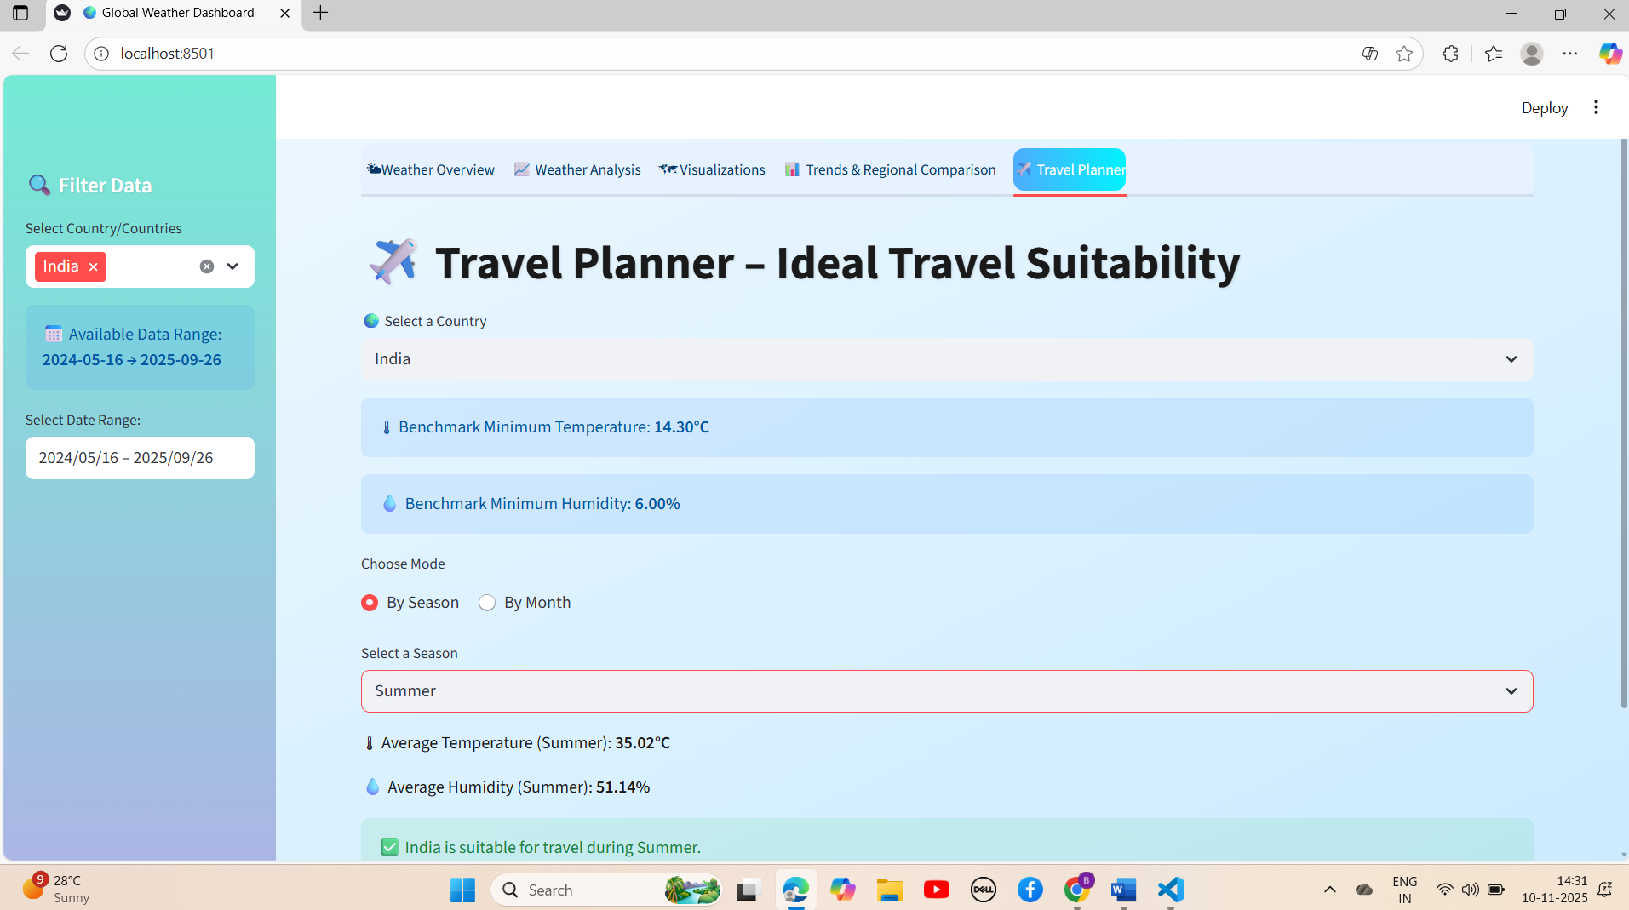

7. Improvements and New Features
- Added sidebar filters and country selectors.
- Designed interactive choropleth and bubble maps.
- Added seasonal and regional trend comparison.
- Introduced travel planner with weather suitability logic.
- Enhanced UI aesthetics using custom CSS and color themes.

8. Conclusion
The Global Weather Dashboard effectively integrates data cleaning, statistical analysis, and interactive visualization. The enhanced design and interactivity enable users to explore global climate patterns efficiently. The dashboard provides a scalable base for adding predictive analytics and real-time updates in future versions.

